PAC-Poly-Tahiti-Fleet of Otaheite at Oparee-Cook-1786

## The Fleet of Otaheite, assembled at Oparee

33 cm x 20.5 cm copperplate engraving, 36.5 cm x 23.5 cm sheet size, Alexander Hogg, London, 1785

We are pleased to offer this scarce and historically important image of the fleet of war canoes encountered at Tahiti by Captain James Cook on his second voyage of discovery and engraved for the *New, Authentic, Entertaining, Instructive, Full and Complete Historical Account of Captain Cook's First, Second, Third and Last Voyages*[1](http://vi.vipr.ebaydesc.com/ws/eBayISAPI.dll?ViewItemDescV4&item=251731639943&t=1395522164000&tid=10&category=360&seller=regiomontanus&excSoj=1&excTrk=1&lsite=0&ittenable=false&domain=ebay.com&descgauge=1" \l "1) published serially between 1784 and 1786.  The plate was engraved after an original drawing of the flotilla made by the expedition's artist [William Hodges](http://en.wikipedia.org/wiki/William_Hodges) (1744-1797) that he later converted to an impressive (if somewhat embellished) oil painting now in the National Maritime Museum.  Trained as a landscape artist, Hodges's orders from the Admiralty as conveyed to Cook were to "diligently employ himself in making Drawings or Paintings of such Places as you may touch that may be worthy of notice in the course of your Voyage as also of other Objects and things as may fall within the Compass of his Abilities", orders that Hodges certainly met and exceeded as this dramatic scene demonstrates.  Cook in his journals his impressions of the fleet:

"...we saw a number of war-canoes coming round the point of Oparree. Being desirous of having a nearer view of them, accompanied by some of the officers and gentlemen, I hastened down to Oparree, which we reached before all the canoes were landed, and had an opportunity of seeing in what manner they approached the shore. When they got before the place where they intended to land, they formed themselves into divisions, consisting of three or four, or perhaps more, lashed square and close along-side of each other; and then each division, one after the other, paddled in for the shore with all their might, and conducted in so judicious a manner, that they formed and closed a line along, the shore, to an inch. The rowers were encouraged to exert their strength by their leaders on the stages, and directed by a man who stood with a wand in his hand in the forepart of the middlemost vessel. This man, by words and actions, directed the paddlers when all should paddle, when either the one side or the other should cease, &c.; for the steering paddles alone were not sufficient to direct them. All these motions they observed with such quickness, as clearly shewed them to be expert in their business. After Mr Hodges had made a drawing of them, as they lay ranged along the shore, we landed and took a nearer view of them, by going on board several. This fleet consisted of forty sail, equipped in the same manner as those we had seen before, belonged to the little district of Tettaha, and were come to Oparree to be reviewed before the king, as the former fleet had been."2

Beautifully engraved with excellent fidelity to Hodges's original drawing, this example of the print presents an exceptionally strong and dark impression and will make a elegant presentation if matted and framed as well as an important addition to any collection related to the explorations of James Cook.

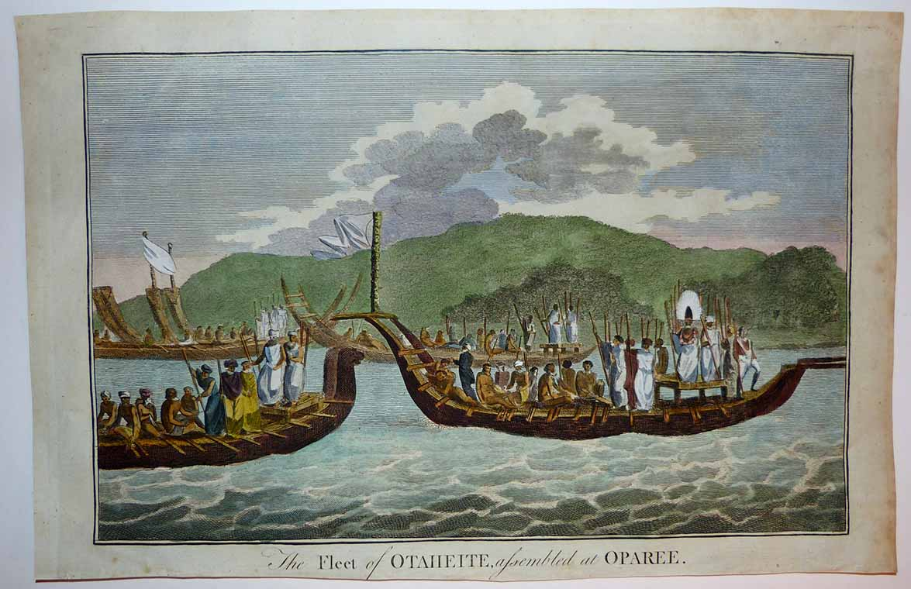

Hodges made no attempt to provide the war canoes with anywhere near the number of crew that Cook estimated, and although several warrior chieftains were wearing the enormous ceremonial helmet seen below, he elected to depict just one, thus making it a focal point of the image.   In their monumental four-volume work *The Art of Captain Cook's Voyages*3 authors Rüdiger Joppien and Bernard note that "Hodges is not seeking to falsify the written accounts deliberately; he is following the time hallowed principles of classical composition, a pictorial and literary tradition that insisted upon the use of a few figures rather than many, so that each figure could be accorded a distinct role in the painting by virtue of its expression, gesture and movement."

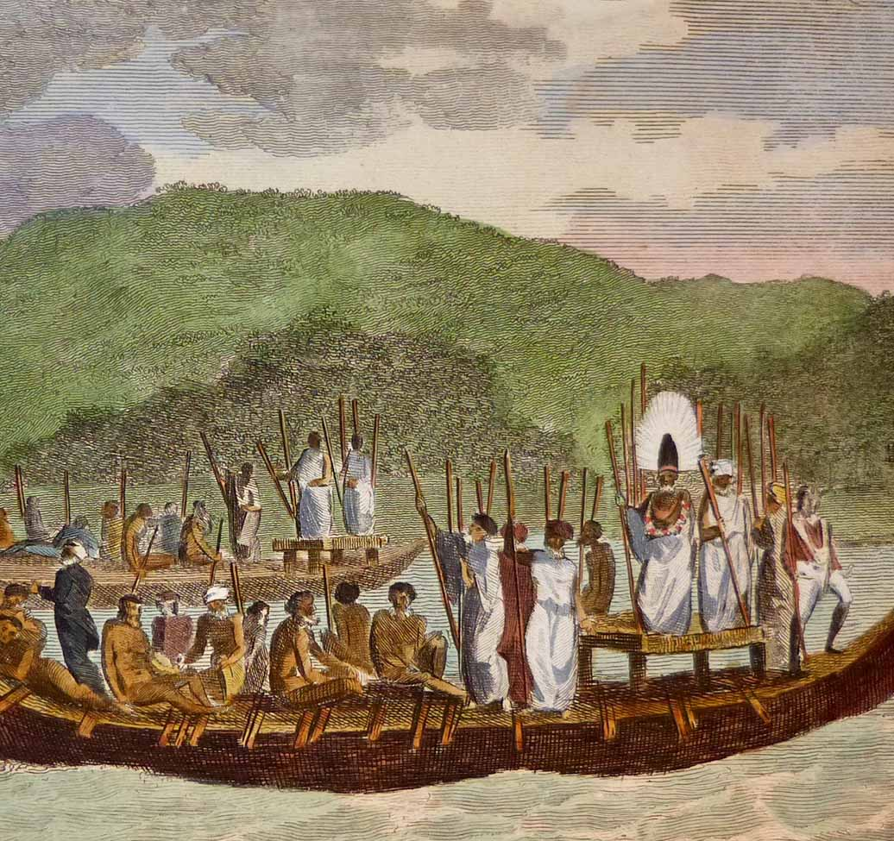

To get a sense of print detail consider that the flagpole on the canoe at right as seen below measures just 4 cm tall actual size:

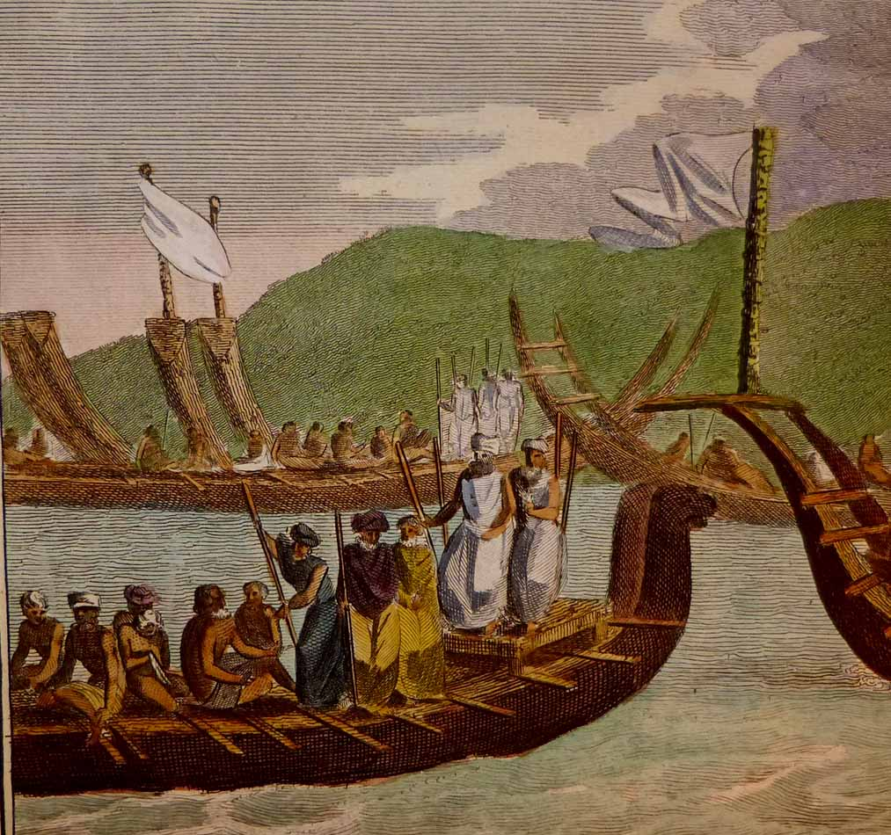

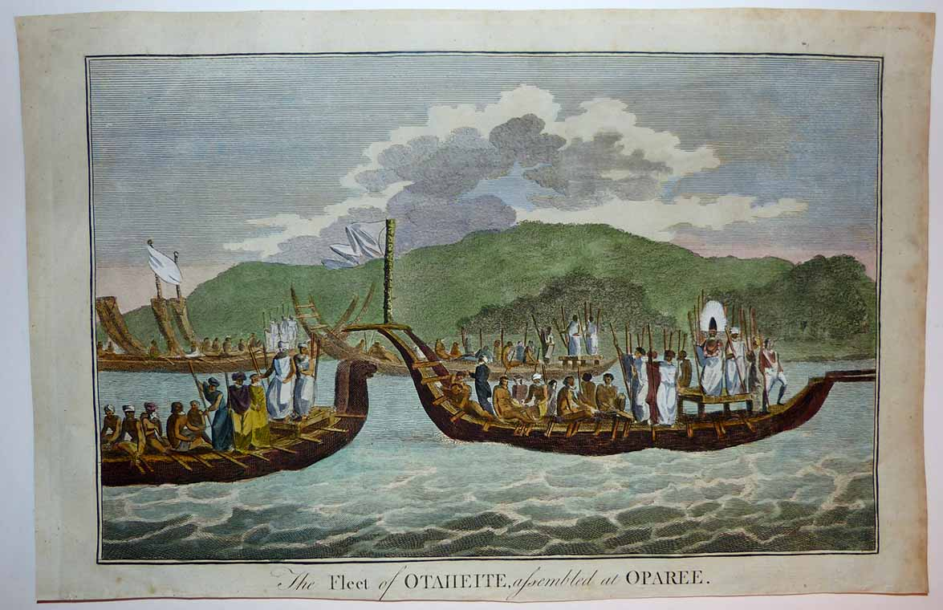

Condition - Please note carefully:  The print is in overall very good condition as can be ascertained from photos, strong impresssion on fine quality laid paper, image area essentially pristine, no text on verso, no folds.  Somewhat close and slightly uneven trim to all margins - just outside platemark on top and side margins and beyond platemark in bottom margin.  Two tiny pinholes in sky at upper right, one slightly larger in top right margin, trivial scattered soiling to margin extremities.  [Inquiries](mailto:jfazli@ix.netcom.com) welcome and we encourage you to visit our other [listings](http://cgi6.ebay.com/aw-cgi/eBayISAPI.dll?ViewListedItems&userid=regiomontanus&sort=3&since=-1) on eBay.  Image of print shows it lying flat in free state with all edges shown for evaluation.  
  
NOTES:  
  
1. The editor of the *New, Authentic, Entertaining, Instructive, Full and Complete Historical Account of Captain Cook's First, Second, Third and Last Voyages* was named as one "George William Anderson",  almost certainly a pseudonym for the publisher Alexander Hogg.  In a recent exhibition of these historically important engravings made for this publication the Lowe Art Museum in Miami noted that the pseudonym was "a device Hogg employed in a number of his publications" intended to convey an "aura of authoritative knowledge" regarding his editing of the official publications of the voyages.  Hogg shrewdly elected to publish the work (which eventually included accounts of other circumnavigations) in a relatively affordable serial format from 1784-1786 to reach a broad audience, noting in his marketing copy that this was "due to the many thousands of Persons who would wish to peruse the Discoveries... and view the astonishing fine Copper-Plates, who have hitherto been excluded from gratifying their eager curiosity.  These installments would allow every Person, whatever may be his Circumstances, to read about the voyages of which such vast Sums of the Public Money have been expended."  
  
2. Cook, James. *A Voyage Towards the South Pole and Round the World: Performed in His Majesty’s Ships the Resolution and Adventure, in the Years 1772, 1773, 1774 and 1775*. 1st ed. 2 vols. London, 1777  
  
3. New Haven; Four Volumes, Published for the Paul Mellon Centre for Studies in British Art by Yale University Press 1985-1988.